Patient Mortality Dashboard Report
Tools Used: MS Excel, PostgreSQL (PgAdmin), Power BI

1. Executive Summary
This report presents a dashboard-driven analysis of in-hospital mortality patterns to identify high-risk patient segments and support data-informed clinical planning. The analysis combines cleaned hospital data, SQL-based KPI extraction, and Power BI visualization.
From the dashboard, the key outcomes include:
- Total Patients: ~87K
- Total Hospital Deaths: 7,273
- Overall Mortality Rate: 8.31%
The analysis indicates elevated mortality concentration among older age groups and specific comorbidity segments, with variation across ICU categories and length-of-stay patterns. These findings can support early-risk stratification and ICU resource optimization.
2. Project Objective
The objective of this project is to convert raw patient records into actionable mortality insights and answer the following business/clinical questions:
- Which patient groups contribute most to hospital mortality?
- How does mortality vary by age, gender, comorbidity, and ICU context?
- Which operational indicators (e.g., ICU LOS) align with worse outcomes?
- What practical actions can reduce preventable mortality risk?
3. Data and Scope
3.1 Data Source
- Source file: raw DATA :- Data processing and KPI extraction were performed using SQL.
3.2 Scope of Analysis
- Population: In-hospital patient records available in the dataset.
- Coverage dimensions:
a. Demographic: age interval, gender
b. Clinical: comorbidity segments
c. Operational: ICU type, ICU admission source, ICU length of stay
d. Outcome: hospital mortality status

4. Methodology
- Data cleaning in Excel
- SQL transformation in PostgreSQL
- KPI extraction using SQL
- Dashboard built in Power BI

5. Dashboard Overview
- Top KPI strip: total patients, total deaths, mortality rate, summary demographics
- Distribution visuals: mortality by age group, gender, and comorbidity category
- Operational visuals: average ICU LOS by ICU type/source and related outcomes
- Summary table: age-group death contribution and totals

6. KPI Definitions (Report-Grade)
- Total Patients - Count of all unique patient records included in analysis.
- Total Hospital Deaths - Count of patients with hospital outcome = deceased.
- Mortality Rate (%) - (Total Hospital Deaths / Total Patients) × 100
- Deaths by Age Group - Number of deceased patients within each age interval.
- Deaths by Comorbidity Type - Distribution of deceased cases across comorbidity categories.
- Average ICU Length of Stay (LOS) - Mean ICU stay duration (days), segmented by ICU type/source and outcome where applicable.
7. Key Findings (From Dashboard)
7.1 Overall Mortality Burden
- The dashboard indicates 7,273 deaths out of approximately 87K patients.
- Overall mortality rate is approximately 8.31%, indicating a meaningful clinical risk burden.
7.2 Age-Linked Risk Concentration
- Mortality counts are concentrated in higher age intervals.
- Older patient cohorts represent a major contribution to total deaths.
7.3 Comorbidity-Related Variation
- Mortality contribution differs significantly by comorbidity segment.
- Specific comorbidity categories carry disproportionately high death share.
7.4 ICU and LOS Patterns
- ICU categories show variation in average LOS.
- LOS and ICU context align with differences in adverse outcomes, suggesting varying severity.
7.5 Demographic Patterning
- Gender and age distributions indicate population structure effects that should be considered in risk stratification.

8. Recommendations and Business Impact
- Early-risk screening should prioritize elderly and high-comorbidity patients.
- ICU workflow optimization is needed in units with higher LOS and mortality burden.
- Operational planning should align staffing/resources with high-risk periods and cohorts.
- KPI monitoring should be standardized for monthly mortality surveillance.

9. Conclusion
This dashboard project demonstrates how structured SQL analysis and Power BI visualization can transform hospital records into practical mortality intelligence. With clear KPI monitoring and targeted intervention on high-risk cohorts, healthcare teams can improve decision quality, optimize ICU operations, and reduce preventable mortality.

10. Annexure
- Dashboard screenshot
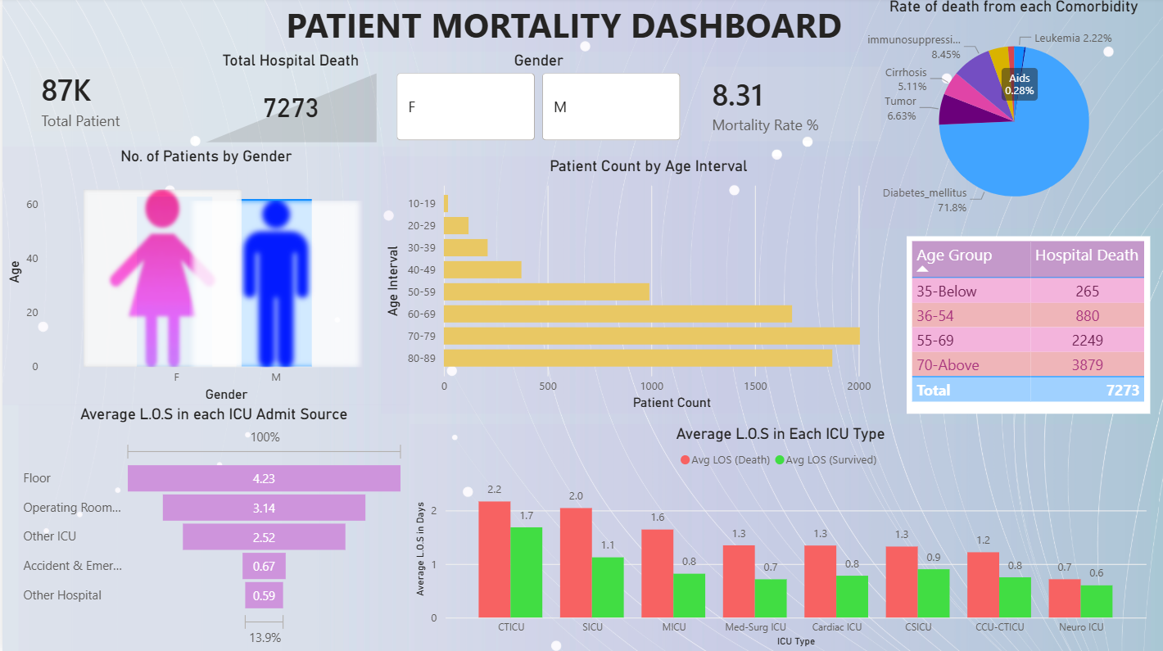
- SQL logic snippets for key KPIs
